**Inquiry Bot Documentation**

Table of Contents

1. Introduction

- Purpose

- Scope

- Features

2. Functionality

- How the Bot Works

- Interaction Flow

- Key Features

3. User Guide

- Accessing the Bot

- How to Start a Conversation

- Available Queries

- Troubleshooting

4. Dependencies

- Libraries Used

- External APIs

- Data Handling

5. Appendices

- Sample Conversations

- Glossary

- Authors and Contact Information

1. Introduction

***Purpose***

This documentation provides comprehensive details about the AICSSYC '23 Inquiry Bot, which is designed to answer user queries related to AICSSYC '23 and previous editions, IEEE Computer Society, and IEEE Computer Society Kerala Chapter.

***Scope***

The Inquiry Bot aims to facilitate seamless interactions by addressing inquiries and providing relevant information. Users can access this bot via the <https://mnandini-2004.github.io/INQUIRY_BOT/> website.

***Features***

- Inquiry Bot for AICSSYC '23

- Answers questions about previous AICSSYC editions

- Provides information about IEEE Computer Society and IEEE Computer Society Kerala Chapter

2. Functionality

***How the Bot Works***

The Inquiry Bot utilizes Dialogflow, an AI-powered platform, to understand and respond to user queries. It has been trained on a dataset consisting of information from various sources, including AICSSYC websites and social media platforms.

***Interaction Flow***

1. User initiates a conversation with the bot.

2. The bot welcomes the user and awaits their query.

3. User asks questions or seeks information.

4. The bot processes the query and generates responses.

5. The user can continue the conversation or end it.

***Key Features***

- Natural Language Processing (NLP) for user-friendly interactions

- Access to information about AICSSYC '23 and previous editions

- Information on IEEE Computer Society and IEEE Computer Society Kerala Chapter

3. User Guide

***Accessing the Bot***

To access the Inquiry Bot:

- Visit the website: [ <https://mnandini-2004.github.io/INQUIRY_BOT/> ]

***How to Start a Conversation***

- Inititate a conversation

- The bot will greet you and await your query.

***Available Queries***

The Inquiry Bot can respond to queries related to:

- AICSSYC '23 details

- AICSSYC '23 date and venue

-AICSSYC '23 speakers

-AICSSYC '23 early bird rate

- AICSSYC’22 details

- AICSSYC’19 details

- AICSSYC’15 details

- IEEE Computer Society

- IEEE Computer Society Kerala Chapter

***Troubleshooting***

- If the bot doesn't understand your query, rephrase it.

4. Dependencies

***Libraries Used***

The bot utilizes the following libraries:

- Dialogflow SDK

***External APIs***

The bot uses the Dialogflow API for natural language understanding and response generation.

***Data Handling***

Data collected during interactions with the bot is used solely for providing relevant responses. It complies with data protection regulations.

5. Appendices

***Sample Conversations***

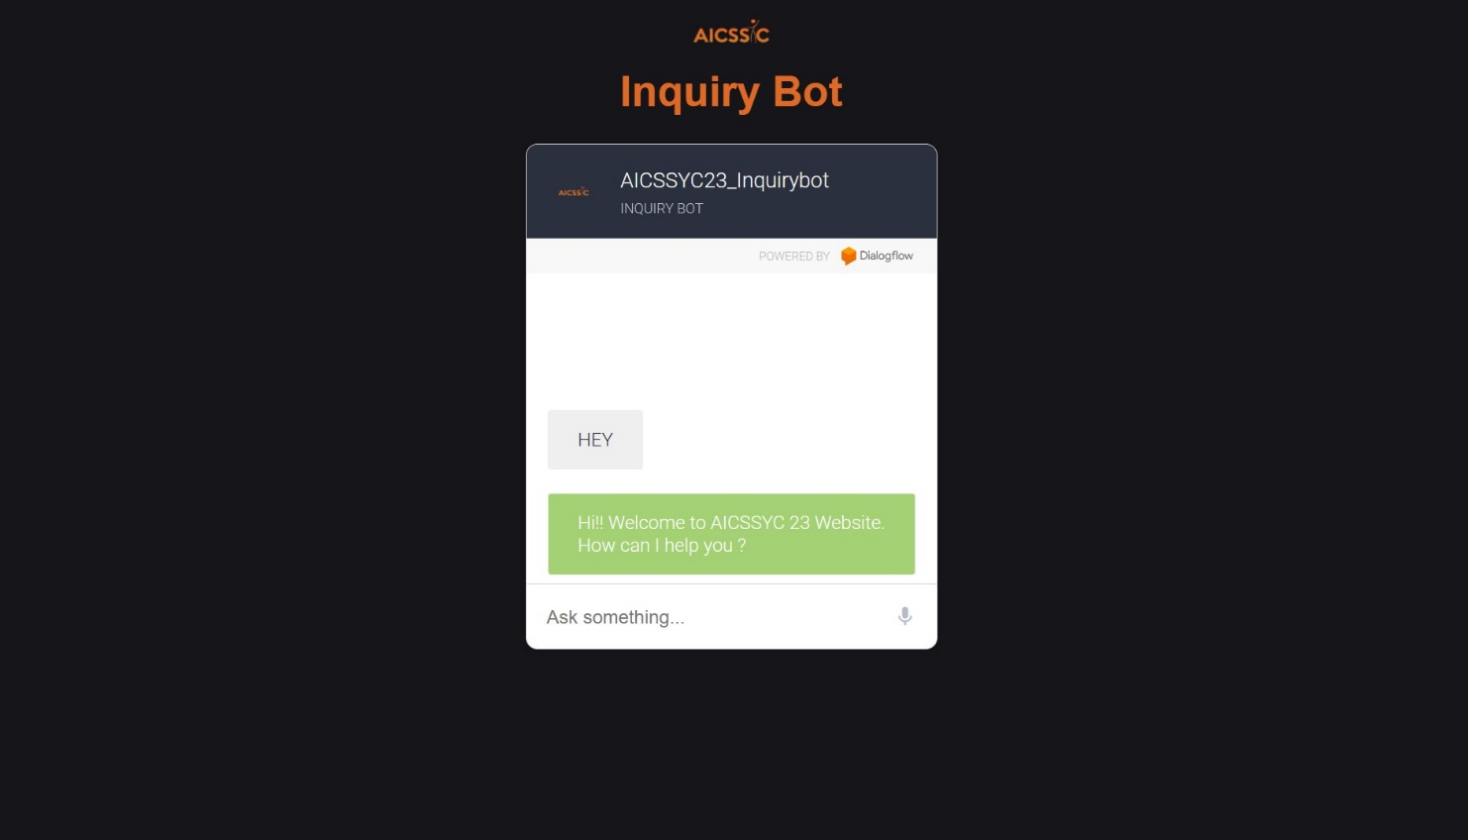

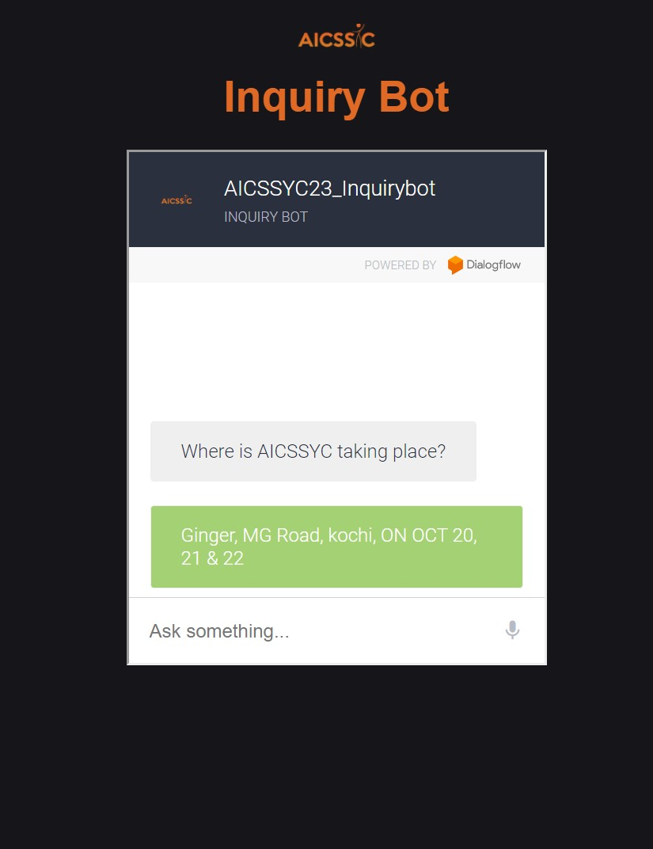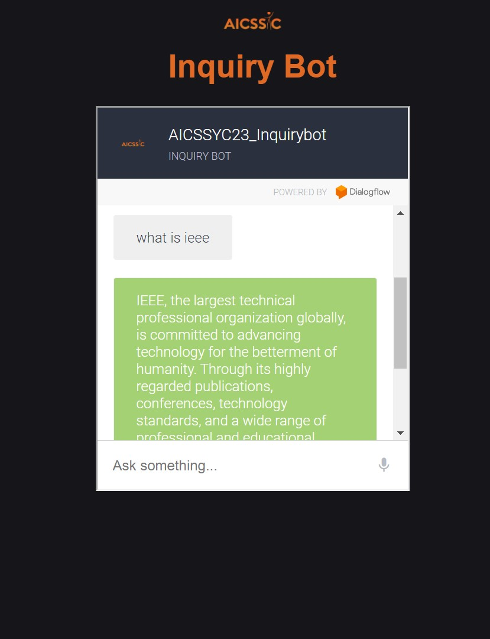

***Glossary***

- NLP: Natural Language Processing

- IEEE: Institute of Electrical and Electronics Engineers

***Authors***

This Bot is a combined effort of M Nandini (6282666134) of SCT College of Engineering & Afsal T S (9567914957) of SCT College of Engineering.

---

This documentation provides a comprehensive overview of the AICSSYC '23 Inquiry Bot, its functionality, and how users can interact with it effectively. It aims to enhance user experiences by offering quick and accurate responses to their queries.